Practice 15
Draw : breathe : relax : draw
Allow yourself five minutes of uninterrupted time. Somewhere you can be seated and have time for yourself.
- Take a piece of paper and draw a rough outline of your body, nothing detailed, more like a child would draw.
- Close your eyes and take a few deep breaths.
- Breathe in for three seconds and out for three seconds.
- Notice where there is any tension in your body -
It might be your temples and forehead - are you frowning?
It might be your neck and shoulders - are the muscles tight?
It might be your stomach - is it knotted with tension or indigestion?
Your skin might be itchy or spotty.
Your hands might be clenched.
Your buttocks might be tight on the seat.
- On your drawing, highlight or shade where the tension is in your body.
- Close your eyes and take some more deep breaths.
- Focus on the tension and see if the deep breathing can help relax it a little, to make it just a few degrees less tense.
- Breathe deep into your belly - and exhale the tension out - make a noise as you exhale.
- Place your hand(s) where the tension is and gently stroke or massage to ease the tension.
- Repeat for as long as it feels right for you.
- Draw another outline of yourself and amend to represent how the tension has reduced.
- Add a little pencil smile to the face.
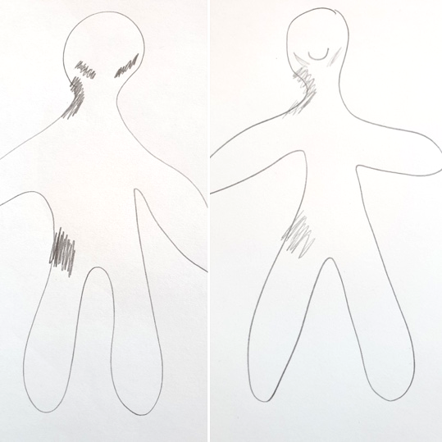
Whenever you notice tightness in your body, breathe slowly and deeply and stroke away the tension. It can gently help you to feel a bit better.

This is the practice for Day 15 taken from the free online programme I created:
Making things better for myself
30 days of self compassion
You can sign up here https://people-intelligence.mykajabi.com/pl/234753

