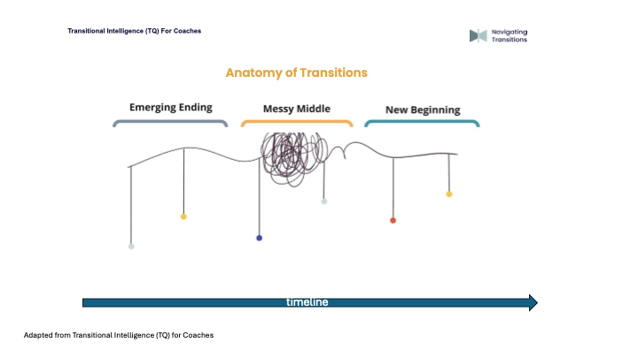
Emerging Ending | Messy Middle | New Beginning

